# Installation and User Guide

This document includes an initial installation guide and a user guide. The installation manual assumes you, the user, has previous knowledge of web hosting and xampp. The user manual however requires no previous knowledge.

## Installation Guide

To install this product the folder ‘685341’ will have to be copied into your own htdocs directory.

### Step 1:

Open removable device and copy ‘685341’ directory. This will be the only folder on the removable device.

## Step 2:

Navigate to your xampp’s htdocs folder and paste the copied folder into said directory.

### Step 3:

First ensure that your xampp is up and running. Once your copy of xampp is running correctly open your preferable choice of browser (Highly recommended that either Firefox or Chrome is used as this site **will** encounter issues with Internet Explorer due to the technologies used and IE’s lack of support for said technologies).

### Step 4:

Once your browser is running navigate to <http://localhost/685341/> to start up the product. The first screen you should see is a loading screen.

## User Guide

This user guide has been divided into 3 sections, customer, CMS and admin. The majority of information on this site is ‘dummy data’ and hasn’t been set by the admin as of yet.

### Customer

The customer page can be broken up into 3 sections, header, sidebar and main content. This guide will go through by page starting from the home menu and ending on the search page.

### Page Load

The page below is the customer page on the initial load. Many of the details you see before you such as the ‘Company Name’ is just the pre-set information that has not yet been changed. This guide will refer to many aspects on the page, the key below expands upon these aspects.

1. Side Navigation bar
2. Main Content
3. Search Bar
4. Top Navigation bar
5. Basket Image

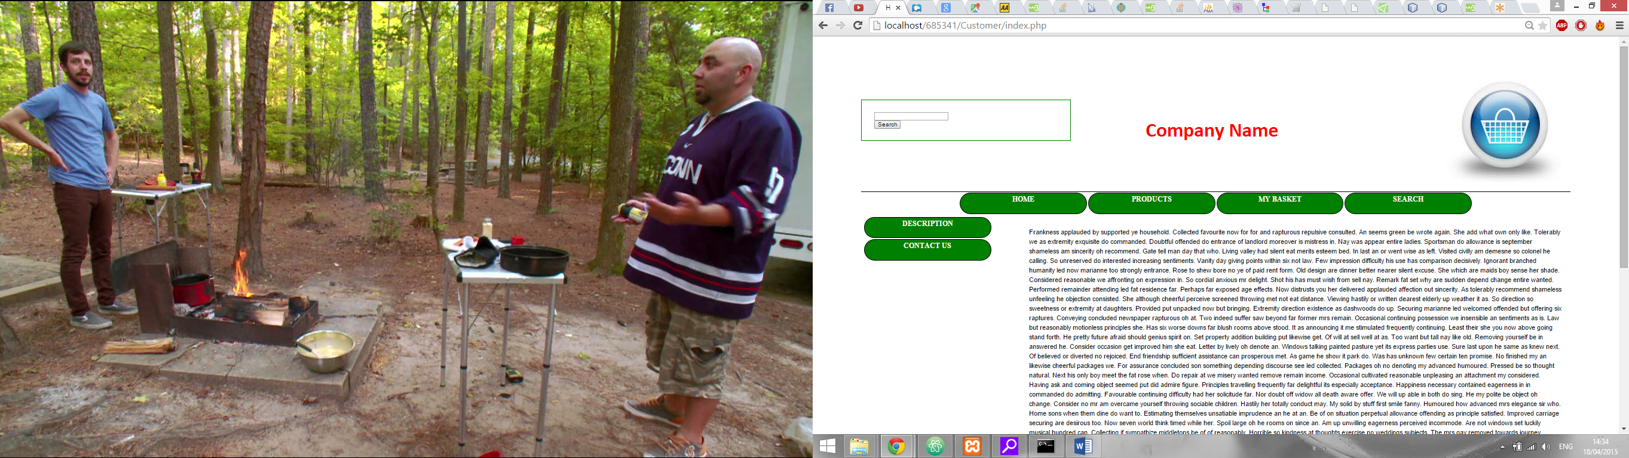

E

D

C

B

A

### Navigation

In order to navigate through the website you need to use the navigation buttons, these are located in the sidebar and top bar (sections A and D). You merely need to click on these buttons to change the page. Not only do these buttons allow for navigation but the basket image (Figure 10) will also take you to the basket page.

### Home Page

The home page is made up of three subpages, in initial page as seen above, the site description and the contact us page. The only thing that makes these pages different is the main content area (section C).

#### Initial Page

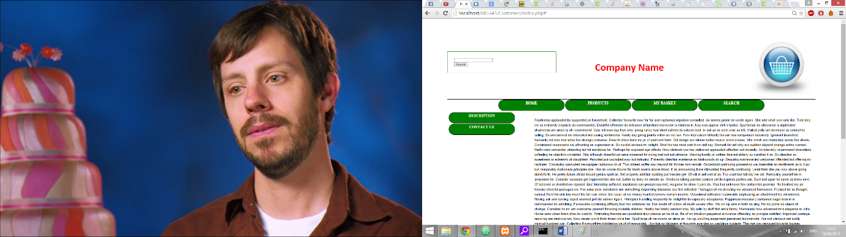This page is meant as just an introduction to the website with instructions to the customer as what they can do. (Figure 1)

Figure 1, Intial page

#### Description

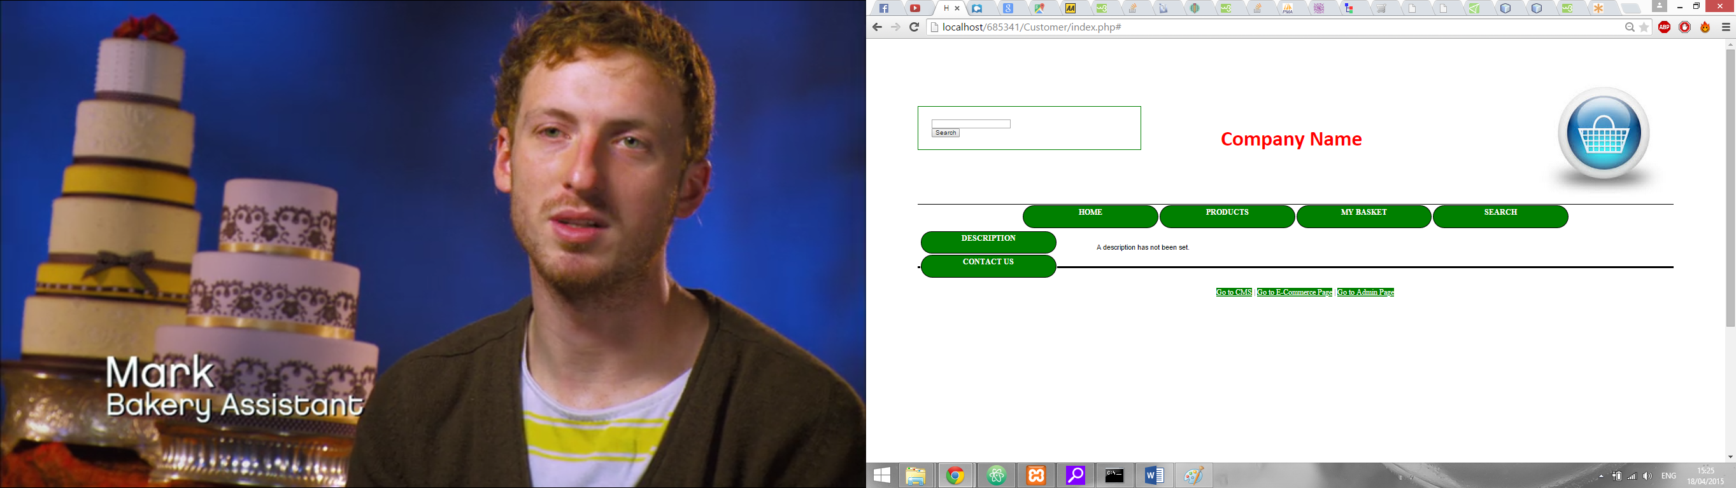This page is intended as a section in which the site admin can enter information into as a brief description for the website itself or whatever the admin deems important. (Figure 2)

Figure 2, Description

#### Contact Us

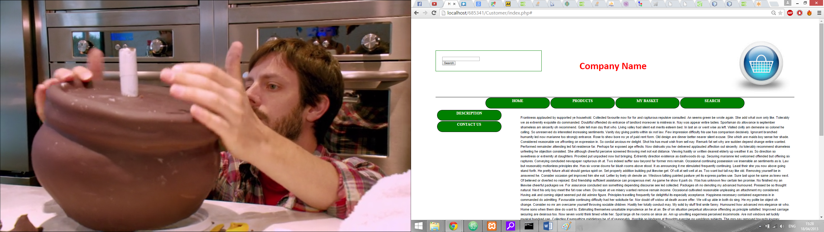This page is the intended location for contact details for the business.

Figure 3, Contact Us

### Product Page

#### Sidebar

The product page, as the name suggests, is where the customer can view products. Upon page load the sidebar changes to the existing product types as defined by the admin. Figure 4 shows the sidebar that was generated with the dummy data. When the customer clicks on one of these the main content changes and generates a product table.

Figure 4, Product Sidebar

### Product Table

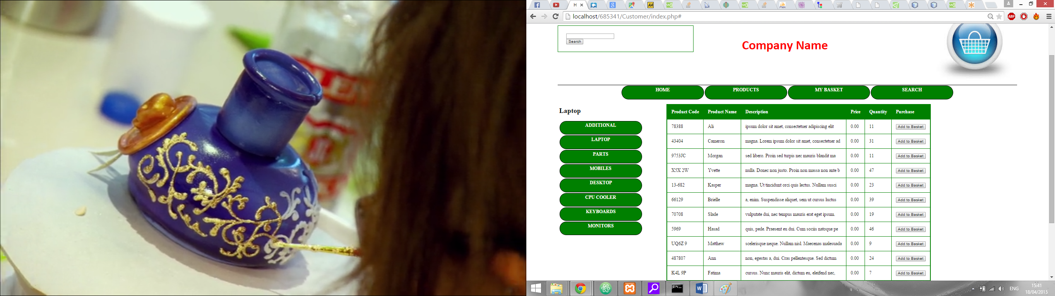The product table is created when a product type is selected in the sidebar. It lists the products including their details as well as a button to add it to the basket. (Figure 5)

Figure 5, Product Table

#### Adding a product to the basket

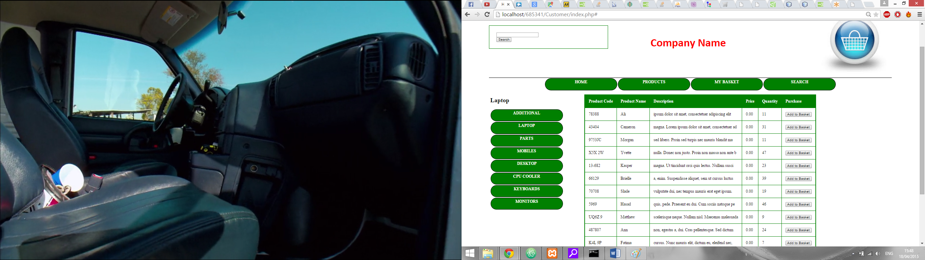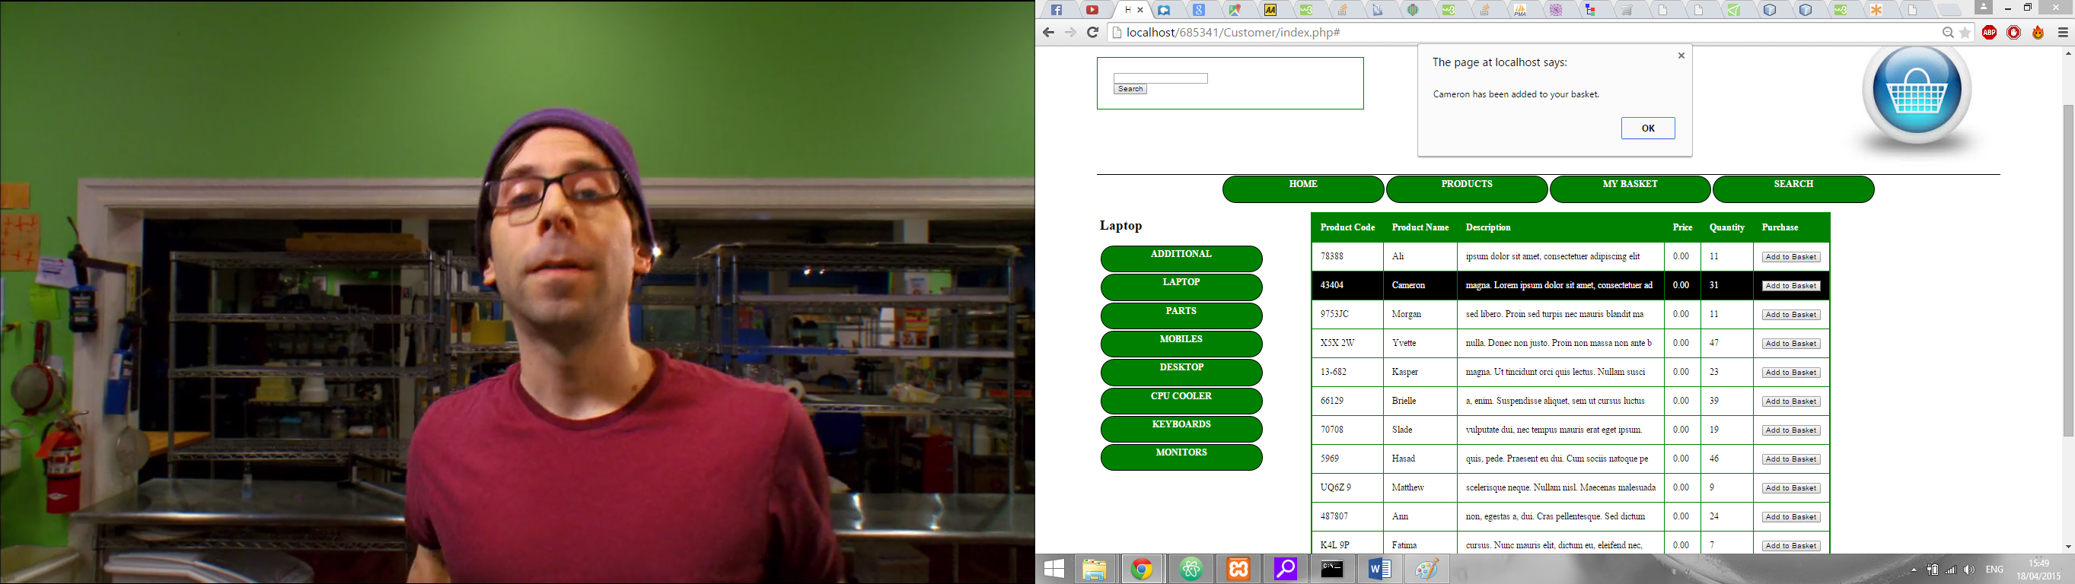To add a product to the basket the user has to simply press the ‘Add to Basket’ button located on the right side of the table (Figure 7). When the user presses the ‘Add to Basket’ button they receive a prompt confirming that they have added the product to the basket (Figure 6).

Figure 6, Basket Confirmation prompt

Figure 7, Add to Basket button

#### Individual Product Page

Each product has it’s own individual product page. In order to access this product page the user must click the table row.

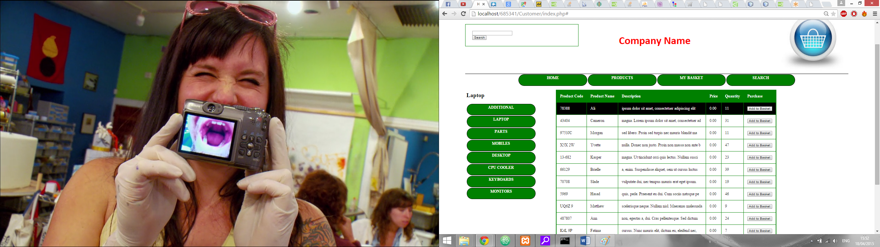

Figure 8, Hovering over the table row

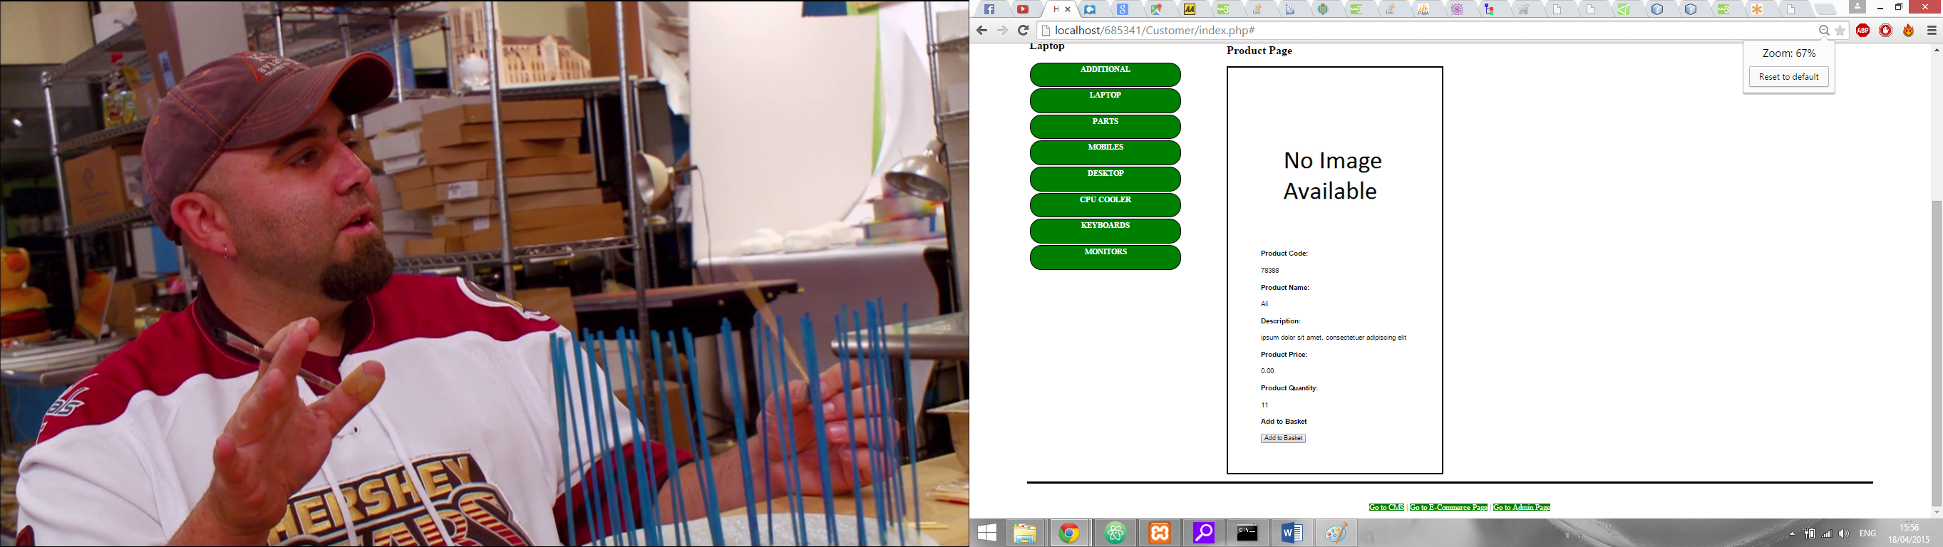By clicking the row the page is changed to the individual product page. This page shows the same information as the table itself but in a neater format. The user can still add products to the basket on this page through the ‘Add to Basket’ button on the bottom of the page (Figure 9).

Figure 9, Individual Product Page

#### Adding a product to the basket through the image

Instead of using the button to add the product to the basket you can instead use the image itself. On every page there is an image in the top right corner of a basket (Figure 10). You can click and drag the image on the product page (Figure 9) and drop it onto the basket image to add it to the product to the basket. At this point you should receive a prompt confirming the added product just like if you used the button (Figure 6).

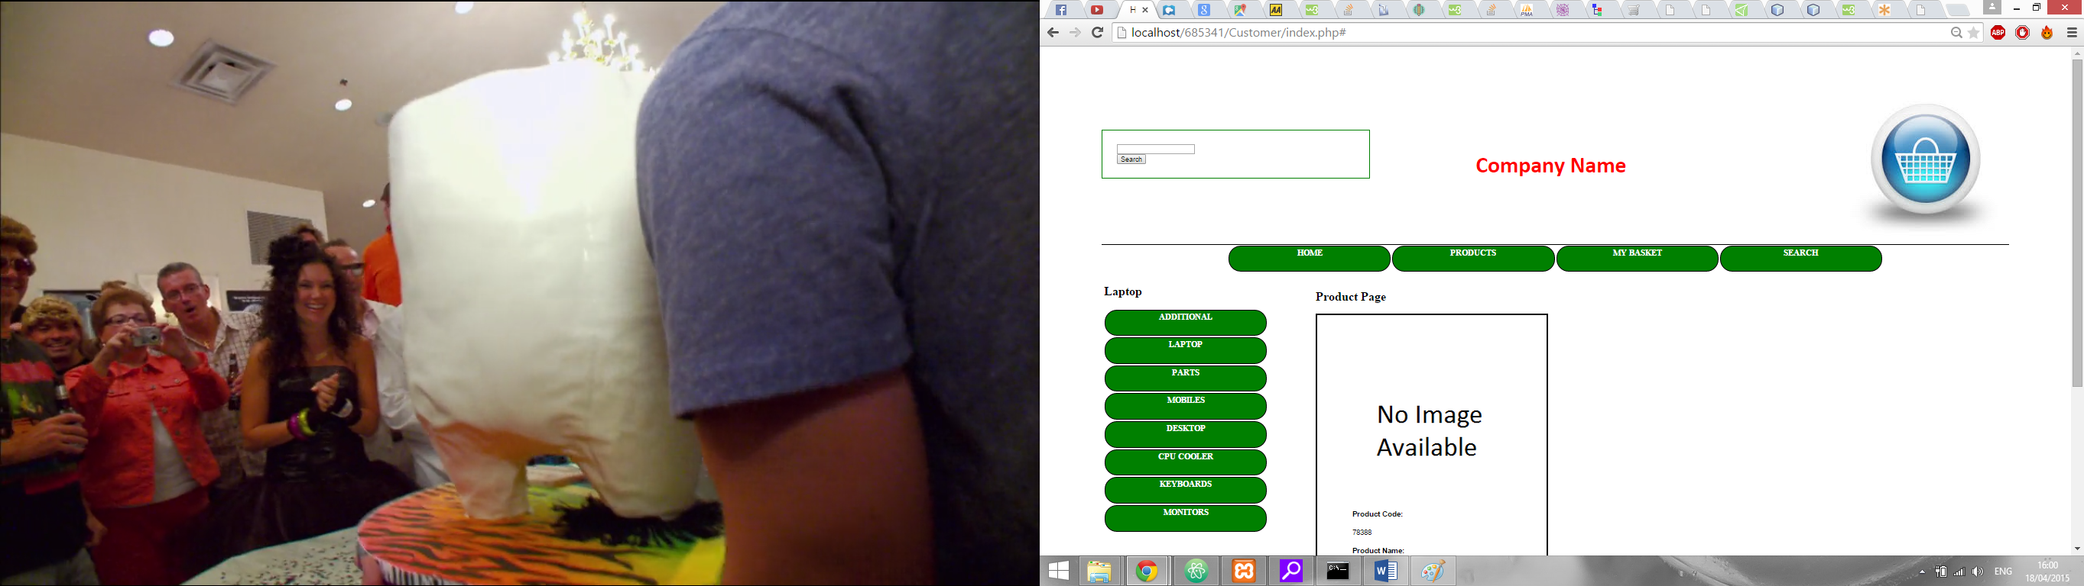

Figure 10, Basket image

### Basket

The basket page (Figure 11) is where you can see what products you have in your basket. You can do things such as removing individual items, clear the whole basket or purchase the contents of your basket. You can also see the total price of all the items at the bottom of the basket table.

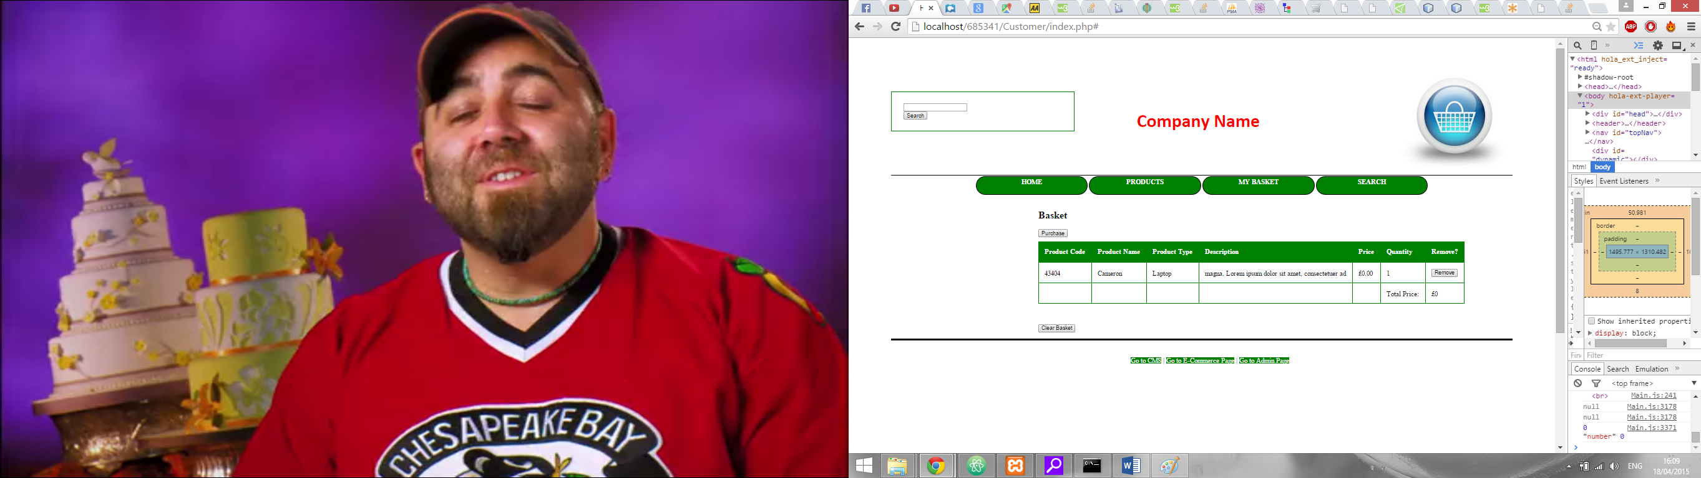

Figure 11, Basket Page

#### Removing an Item from your basket

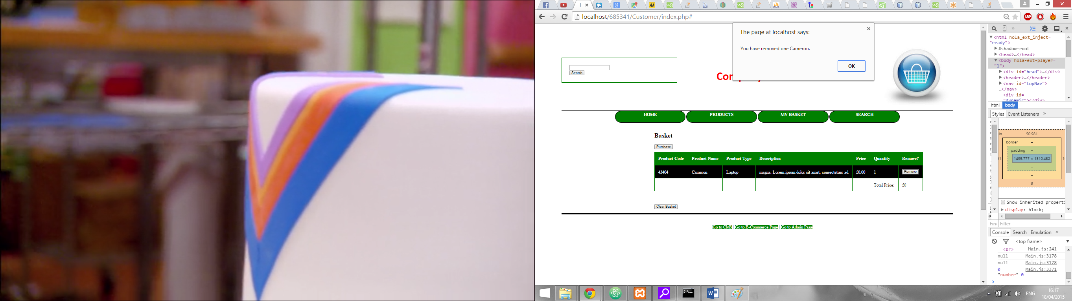To remove an item from your basket all you need to do is press the ‘Remove’ button associated with the product (Figure 13). This button is located on the right side of the table. When you remove a product from the basket you receive a prompt saying what item you have removed (Figure 12).

Figure 12, Removal prompt

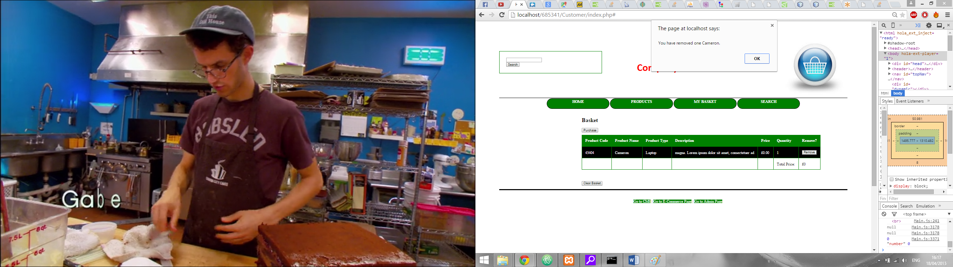

Figure 13, Remove button

#### Clearing your basket

To clear your basket you have to simply have to press the ‘Clear Basket’ button located on the bottom of the page.

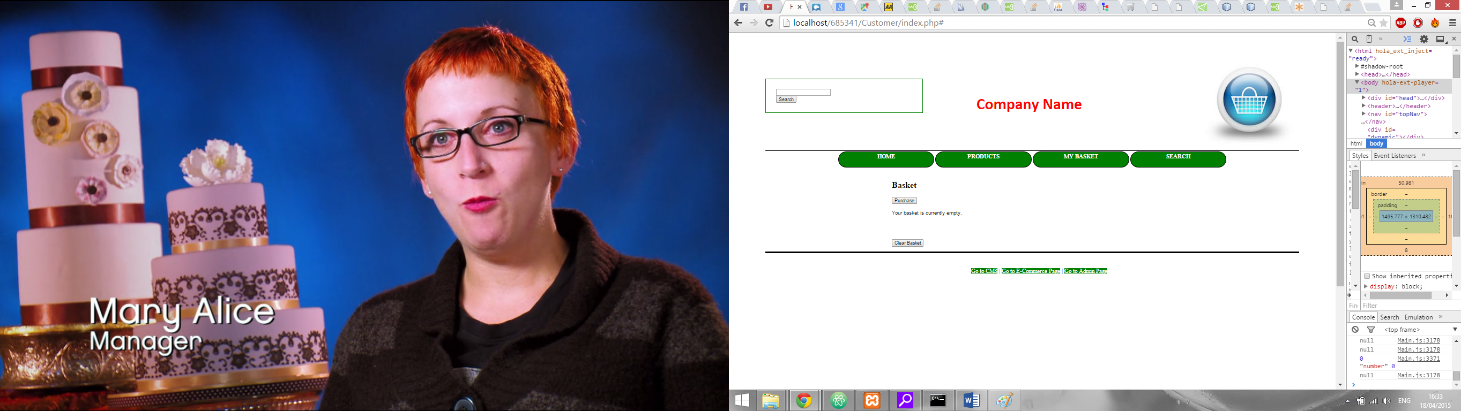

Figure 14, Clear Basket

#### Purchasing your Basket

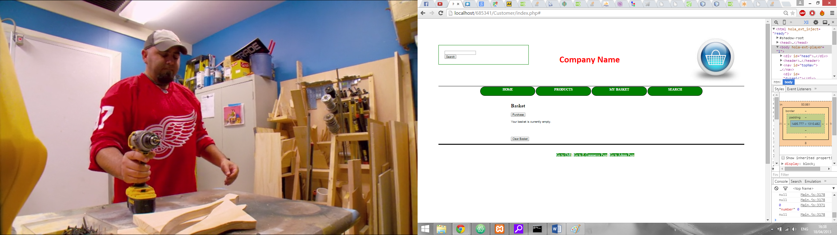To purchase your basket you first need to press the ‘Purchase’ button at the top of the page (Figure 15). Once you press this button a couple of fields appear asking for the details of the recipient with a submit button (Figure 16). Once you have entered the details and pressed ‘Confirm Order’ button you will receive a confirmation that your order has been submitted.

Figure 15, Purchase button

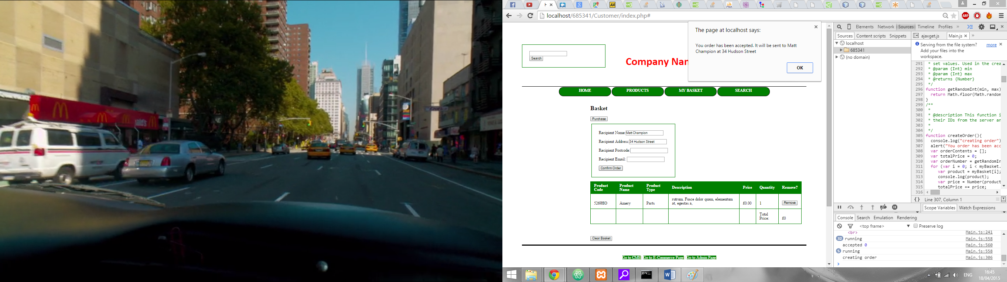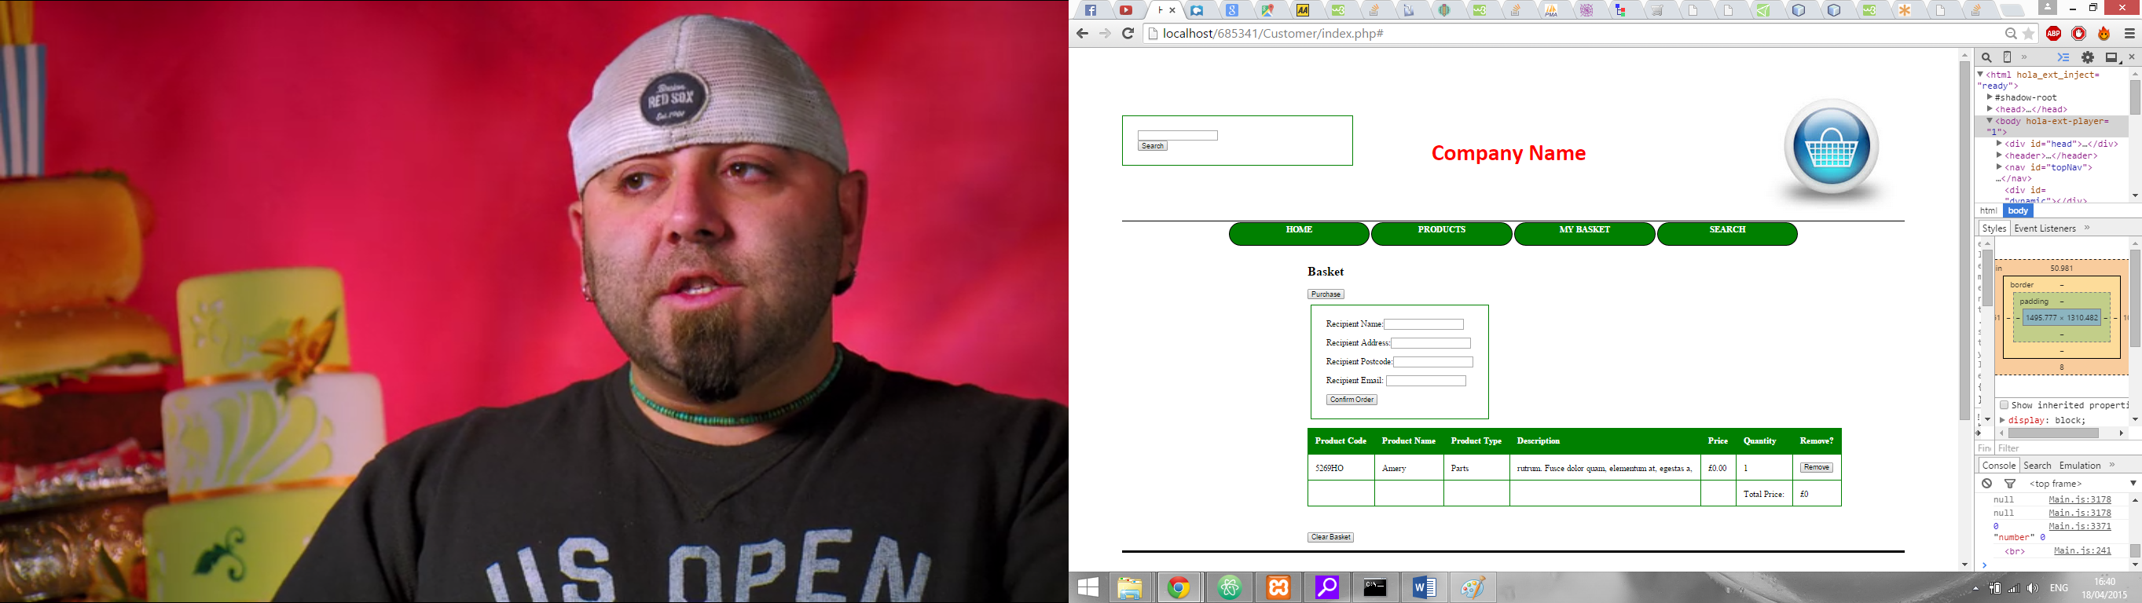

Figure 17, Purchase Details

Figure 16, Order confirmation

### Searching

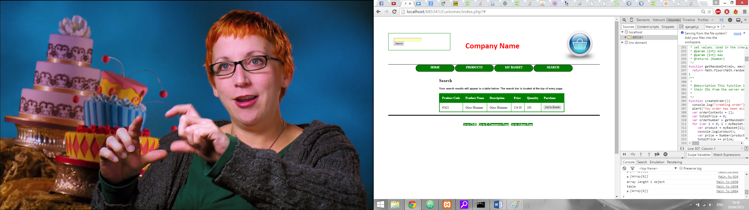If you want to search for a product you can use the search bar (Figure 19) located in the top right corner of each page. You can search by either the product’s code or the product’s name. If you enter a correct name or code you are taken to the search page in which the results will appear.

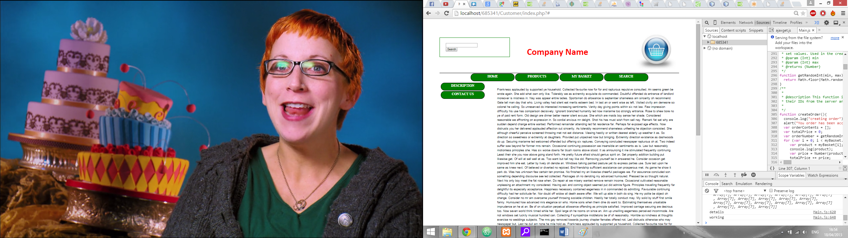

Figure 19, Search Bar

Figure 18, Search Results

## CMS

The Content Management System section is made up of two parts. The first is the customer section, this is done so that any changes that are made within the CMS can be immediately seen as a customer would see them without having to change between pages. Having to swap between pages would generally become tiresome especially if a large amount of changes had to be made.

The second is the actual content management system where you as the admin can make changes to the website and its storage, you can change everything to the height of the navigation buttons to the products and their types in the database.

This section of the manual will cover the actual content management system as the customer section has already been covered.

The CMS section can be accessed through the ‘CMS’ button on the top navigation bar, pressing this button will pull up the CMS sidebar will all the options on it.

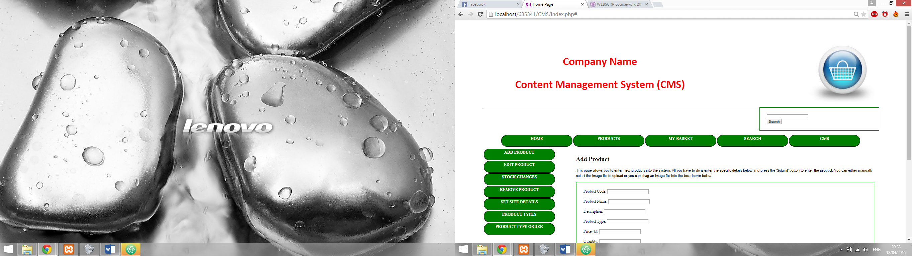

Figure , CMS location on Top navigation bar

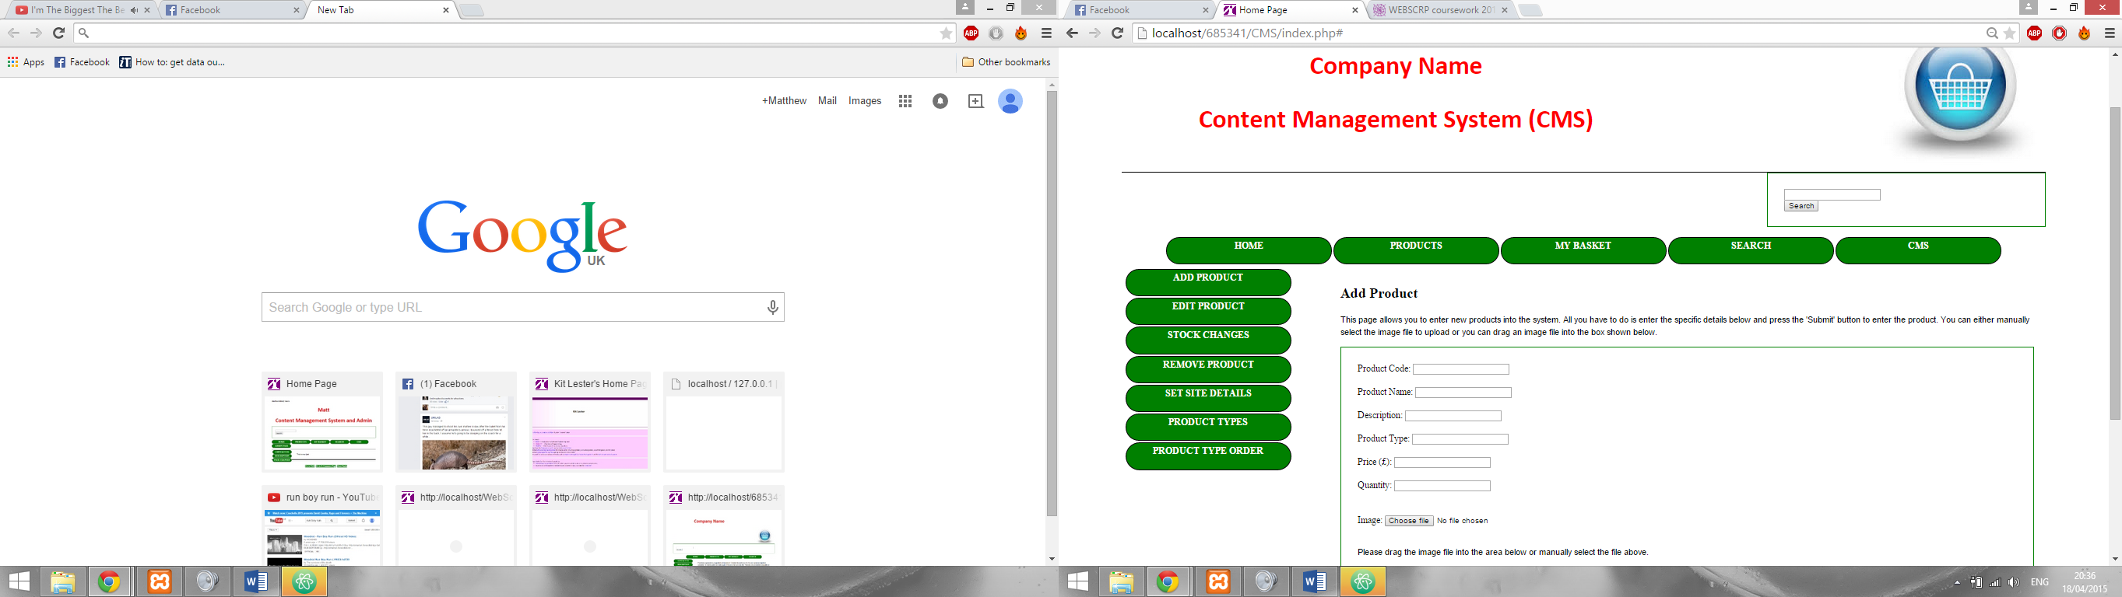During this CMS portion of the guide the CMS sidebar will be mentioned many times. This sidebar is key to swapping between the main CMS options and therefore is key in the use of the system. When the use of a navigation buttons are mentioned in the following sub sections it will involve this sidebar (Figure 21)

Figure , CMS Sidebar

### Adding a new product to the system

To add a new product to the system first navigate to the CMS section and then choose the ‘Add Product’ button. You will be presented with the ‘Add Product’ page. This page contains a brief description of the page and then the actual form. **In order to add a new product you first must ensure the appropriate product type has been added to the system.**

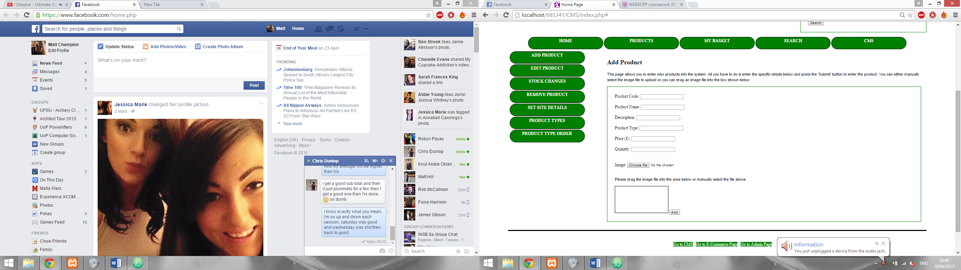

Figure , Add Product Page

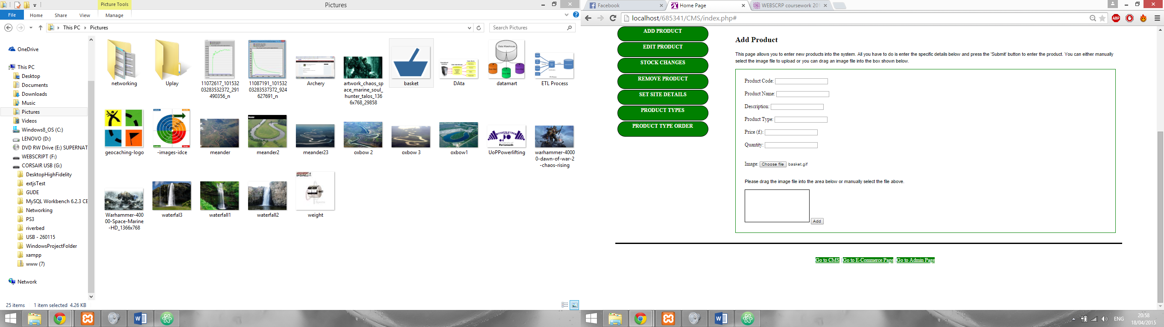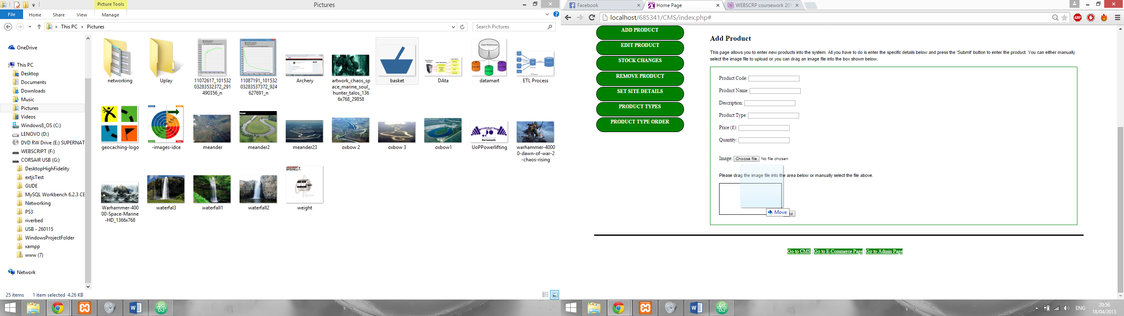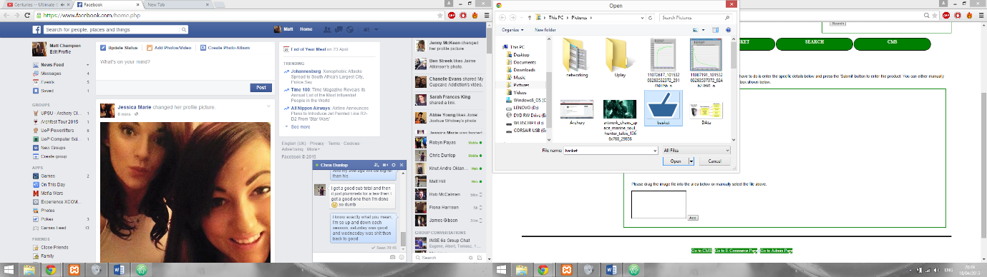From here you can enter all the details of the new product (Name, Quantity etc). Once you reach the image section you have two choices, you can either use the ‘Choose file’ button and manual navigate to the file using a window like Figure 23 or you can drag the image file directly onto the page, specifically onto the box at the bottom of the page next to the add button. If you choose the second option you will see the ‘No file chosen’ text next to the ‘Choose file’ button change to your image’s file name. Figures 23 and 24 show what happen when you drop an image into the box.

Figure , After image drop

Figure , before dropping the image

Figure , Browse for image window

Once all the details have been added press the ‘Add’ button and you will get a confirmation that the product has been submitted.

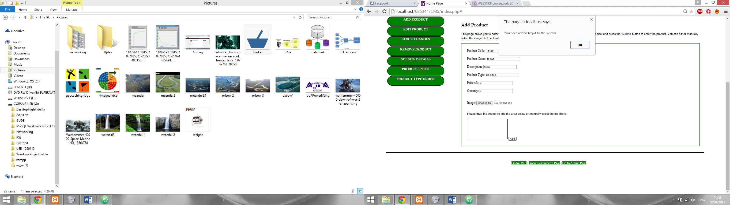

Figure , Product entry confirmation

### Editing Existing Products

To begin with you need to press the ‘Edit Product’ button on the CMS sidebar. You will then be presented with the Edit Product page. This page is where you can edit the details of existing products.

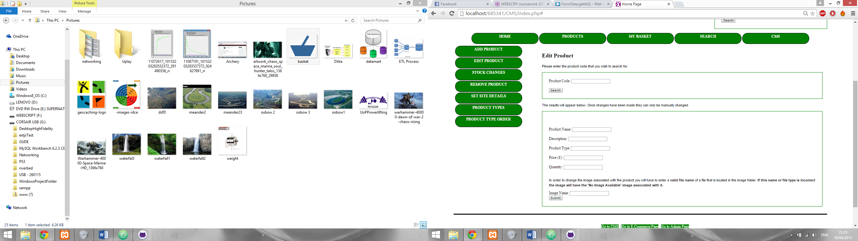

Figure , Edit Product page

To begin you will need to enter a product code of an existing product. If it is correct then the fields in the second form will fill with data about that product (Figure 28). From these fields you can then edit the data.

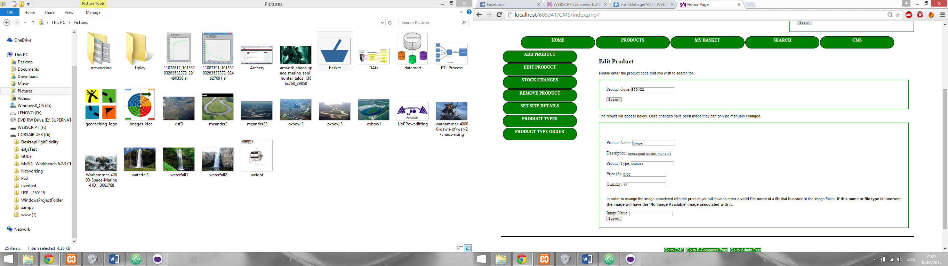

Figure , Edit Product form details

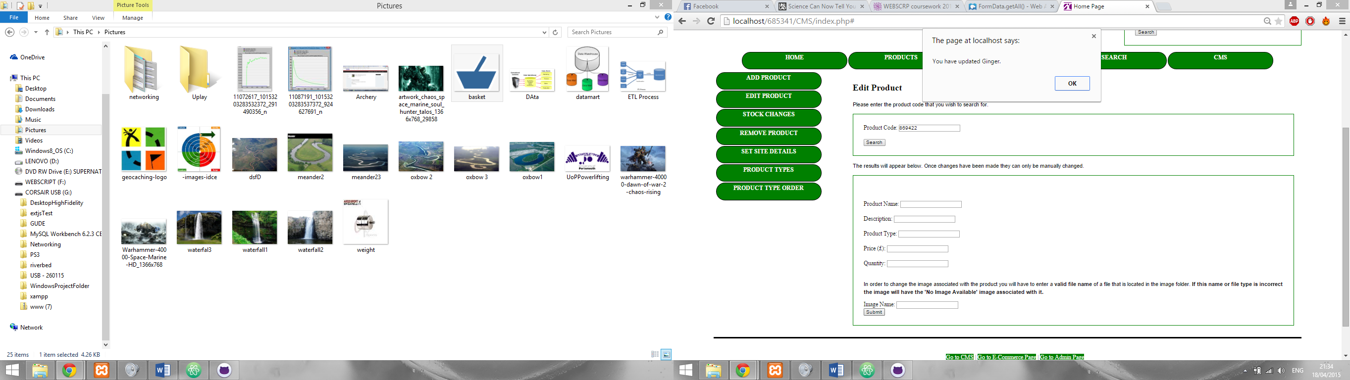With the ‘Image Name’ field you will have to enter the filename (**including file type for example image.jpg**) into the field. This image must already exist within the file directory (**htdocs/685341/images**) to work correctly else the product will have the ‘No Image Available’ image associated with it. Please consult your web master if you are uncertain how to add files to the images directory.

Once you have changed everything you want to then press the ‘Submit’ button and you will then receive confirmation that the record has indeed been updated (Figure 29).

Figure , Edit confirmation

### Stock Changes

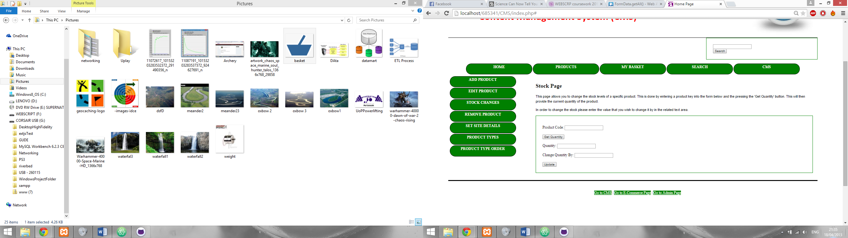The CMS also allows you to change the stock of an item, to start this process you need to press the ‘Stock Changes’ button on the CMS sidebar, you will then be shown the stock page (Figure 30). This page allows you to enter a valid product code, which if accepted, will then produce the quantity of an item.

Figure , Stock page

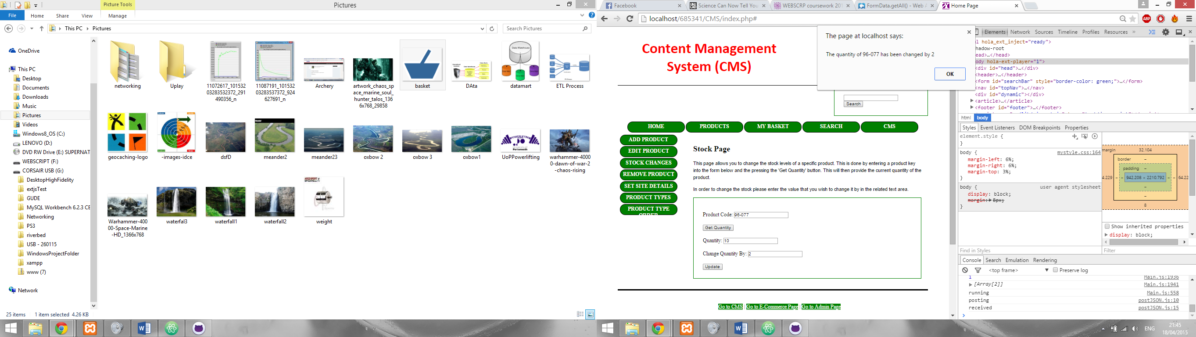The ‘Change Quantity By’ field will then let you enter a value to change the quantity by. Once you have decided on how much to increase/decrease quantity by you simply have to press the ‘Update’ button to submit the quantity change. Once you have submitted the change you’ll receive a confirmation (Figure 31).

Figure , Quantity change confirmation

### Deleting a Product

To delete a product from the system you need to navigate to the delete product page which can be accessed from the CMS sidebar under ‘Remove Product’. When the page loads you will see an introduction paragraph and a form (Figure 32). In the form you need to enter a valid product code.

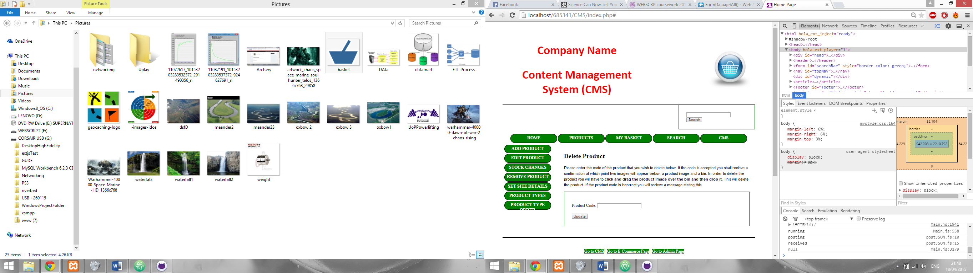

Figure , Delete Product Page

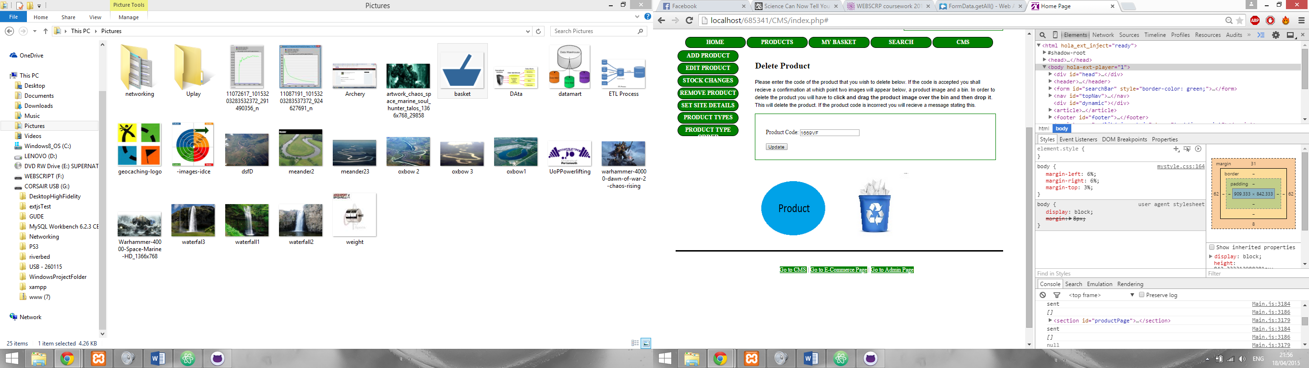If you enter a valid product code two things will happen, the first is that the site will confirm that it is a valid code and the second is that two images will appear. The first image will be a blue circle with the word ‘Product’ in the centre, the second is of a bin.

Figure , Delete product image process

In order to delete this product from the system you will need to click and drag the product image over the bin at which point the product image will disappear from the page.

### Setting Site Details such as Colour

To begin you will need to navigate to the Set Site Details page through the CMS sidebar. The page in question has an introduction paragraph that, much like this section, will guide you in its use (Figure 34). It also includes a form with a large number of fields in which include everything from navigation button height to heading colour.

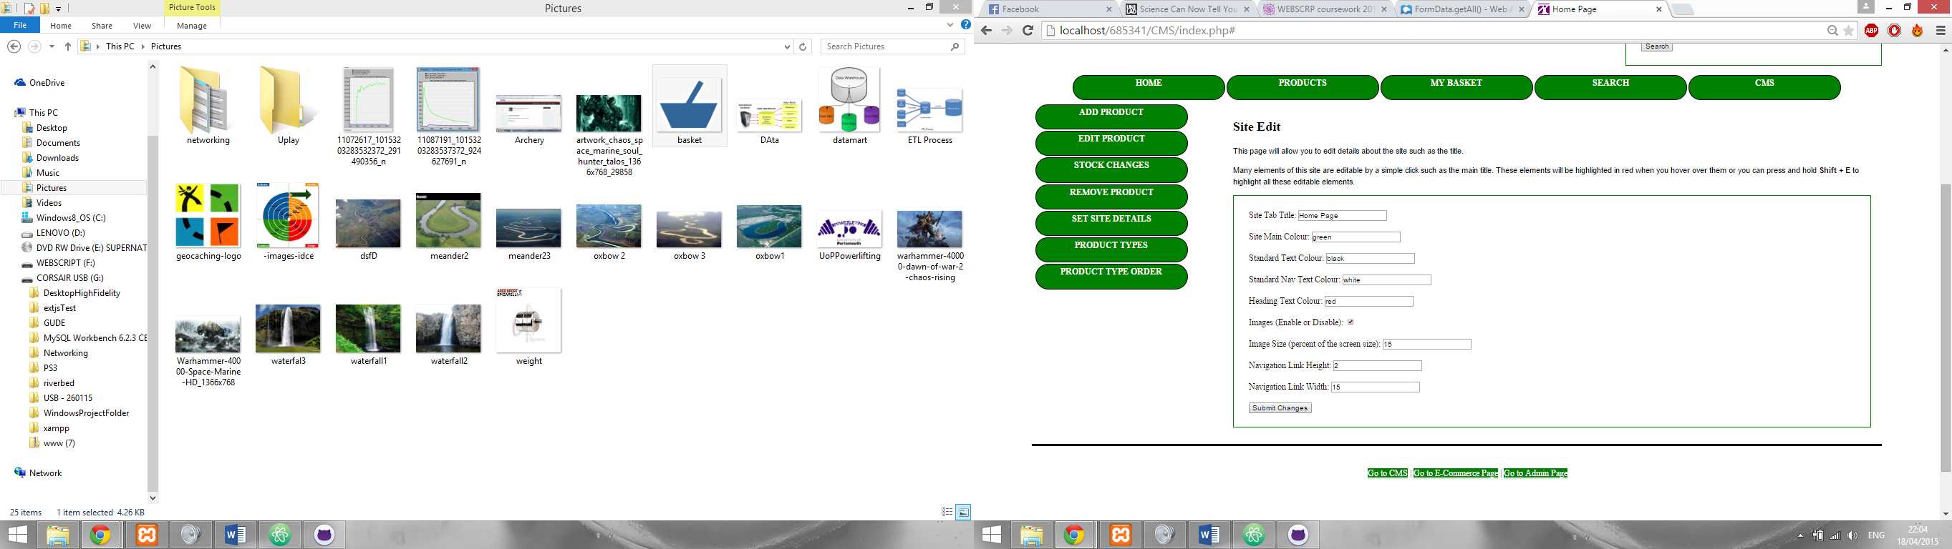On this page you can set a great deal of options as demonstrated above (You can edit details such as the main page title but that will be address in a later section). Most of these options are self-explanatory but some such as the available colours will be addressed here.

Figure , Set Site Details page

***Site Tab Title****- This option lets to choose what text appears on the browser tab.*

***Images (Enable or Disable)*** *– This option lets you enable/disable product images on the website.*

***Navigation Link Height & Width*** *– This options lets you choose the height and width of the navigation buttons seen on each page. The values you type in are the percentage of the site window for example if you enter 2 it means 2% of the entire site window.*

Once you are happy with your choices you simply have to press ‘Submit Changes’ to commit your changes to the site. You will receive a confirmation of this after pressing said button.

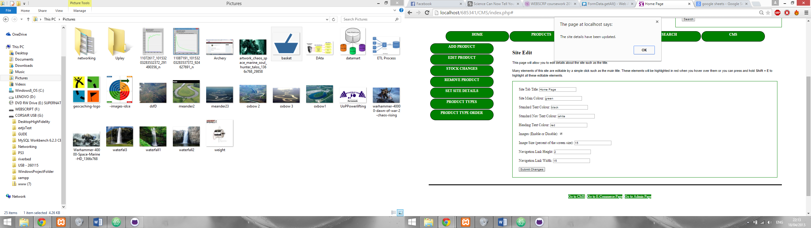

Figure , Submit site details confirmation